**STORED PROCEDURES**

**1.USE `activity1`;**

**DROP procedure IF EXISTS `new_procedure`;**

**DELIMITER $$**

**USE `activity1`$$**

**CREATE PROCEDURE `new_procedure` ()**

**BEGIN**

**select * from production;**

**END$$**

**DELIMITER ;**

**call activity1.new_procedure();**

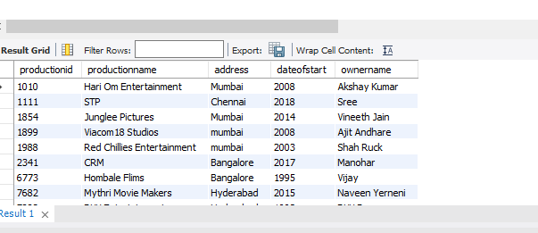

**2.**

**USE `activity1`;**

**DROP procedure IF EXISTS `movie`;**

**DELIMITER $$**

**USE `activity1`$$**

**CREATE PROCEDURE `movie` ()**

**BEGIN**

**select * from movie;**

**select moviename from movie where movietype='drama';**

**END$$**

**DELIMITER ;**

**call activity1.movie();**

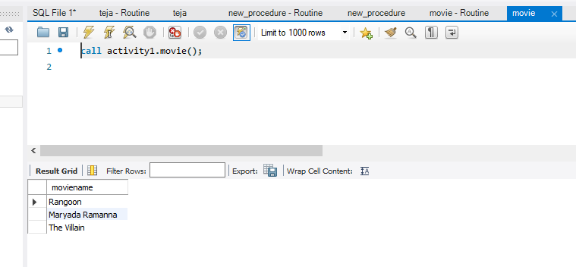

**3**

**USE `activity1`;**

**DROP procedure IF EXISTS `new_procedure1`;**

**DELIMITER $$**

**USE `activity1`$$**

**CREATE PROCEDURE `new_procedure1` ()**

**BEGIN**

**select count(moviename) from movie where length>18;**

**END$$**

**DELIMITER ;**

**call activity1.movie();**

